Course Assignment 1

Draw a model of unlocking a shared bicycle.

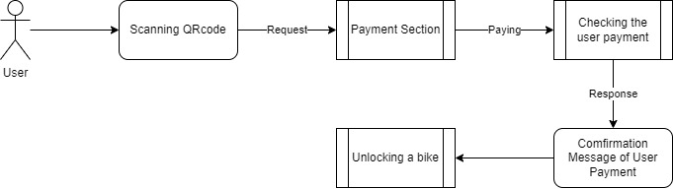

At first, the user will use his mobile phone to scan the QR code of the bike, then the application in the mobile phone will make a request to the server for the Payment Section. After the user finishes his payment section, the server will respond with the Confirmation Message of the Payment, and finally, the bike is unlocking.

Chaiwat Plongkaew 2021326660023